Abstract
Crop Recommendation Systems (CRS) increasingly rely on ensemble-based machine learning models such as Random Forest and XGBoost to support data-driven decision-making in precision agriculture. While these models achieve high predictive accuracy, their black-box nature has motivated the adoption of Explainable Artificial Intelligence (XAI) techniques, most notably SHAP and LIME. However, agricultural data is inherently noisy due to sensor inaccuracies and environmental variability, raising concerns about the reliability of explanations generated under real-world conditions.
This paper investigates the stability of XAI explanations in crop recommendation systems by systematically analyzing the behavior of SHAP and LIME under controlled noise perturbations. We introduce a noise-aware evaluation framework that applies multiple perturbation levels (0%, 2%, and 5%) and distinguishes between Sure and Confused prediction cases based on model confidence. Explanation stability is quantified using rank-based and set-based similarity metrics across repeated perturbation runs.
Experimental results reveal that SHAP explanations remain consistently stable across noise levels, predictive models, and confidence regimes. In contrast, LIME exhibits significant sensitivity to input perturbations, particularly in Confused cases, leading to a pronounced Stability Gap under noisy and uncertain conditions. These robustness patterns are observed consistently across both Random Forest and XGBoost, indicating that explanation instability is largely method-dependent rather than model-specific.
The findings highlight explanation stability as a critical yet underexplored dimension of explainable AI evaluation in agriculture. For high-stakes, real-world crop recommendation systems, the results suggest that SHAP provides more reliable explanations than LIME and should be preferred when robustness and user trust are primary concerns.
1. Introduction
The deployment of machine learning models in precision agriculture has increased rapidly with the growing availability of structured soil and climatic datasets. In this context, Crop Recommendation Systems (CRS) are increasingly used to assist decision-making by mapping environmental and soil conditions to suitable crop categories \cite{liakos2018machine}. Such systems are particularly relevant in regions where suboptimal crop selection can result in substantial yield loss and inefficient resource utilization.
Among the various modeling approaches explored for CRS, ensemble-based classifiers such as Random Forest and Extreme Gradient Boosting have demonstrated strong empirical performance on heterogeneous agricultural data \cite{kamilaris2018deep}. Their ability to capture complex, non-linear interactions between soil nutrients, weather conditions, and crop requirements makes them attractive for real-world deployment. However, these advantages come at the cost of reduced transparency, as the internal decision processes of such models are not directly interpretable.
To address this limitation, model-agnostic Explainable Artificial Intelligence (XAI) methods have been widely adopted to accompany CRS predictions. In particular, SHAP \cite{lundberg2017shap} and LIME \cite{ribeiro2016lime} are commonly employed to attribute a model’s prediction to individual input features. In agricultural settings, these explanations are often presented as evidence for why a specific crop is recommended, for example, by highlighting the relative influence of nitrogen content, rainfall, or soil pH. In the absence of stable and consistent explanations, farmers may be unable to trust or act upon AI-generated recommendations, particularly when agronomic decisions carry financial risk.
Despite their growing use, the reliability of such explanations under realistic data conditions has not been sufficiently examined. Agricultural input features are typically derived from sensors or estimations that are subject to measurement error and temporal variability. As a result, small perturbations in input values are unavoidable in operational CRS pipelines. If explanation outputs vary substantially under these minor perturbations, the explanatory mechanism may become unreliable, even when predictive accuracy remains unchanged.
This observation motivates the present study, which focuses on the stability of XAI explanations rather than their interpretability alone. We define stability as the degree to which feature attributions remain consistent when input data is subjected to controlled noise. Furthermore, we distinguish between predictions made with high confidence and those made under uncertainty, as explanation reliability is expected to be particularly critical in ambiguous decision scenarios.
2. Related Work
2.1 Crop Recommendation Systems
Early research on crop recommendation systems explored traditional machine learning approaches that model the relationship between soil characteristics, climatic variables, and crop suitability. Techniques such as Support Vector Machines (SVM), naïve Bayes classifiers, and decision trees were widely adopted due to their simplicity and interpretability. Several studies demonstrated the feasibility of using nutrient composition and weather data for crop classification, although performance often degraded when faced with heterogeneous or high-dimensional agricultural datasets \cite{liakos2018machine}.
To overcome these limitations, ensemble-based learning methods gained traction in agricultural decision support systems. Random Forest (RF) models, in particular, were shown to provide improved generalization and robustness by aggregating multiple decision trees, making them well-suited for noisy agricultural data \cite{kamilaris2018deep,breiman2001random}. More recently, boosting algorithms, such as XGBoost, have been employed to further enhance prediction accuracy by iteratively focusing on difficult-to-classify samples. Empirical studies report that boosting-based CRS outperform traditional models, especially in multi-class crop recommendation settings involving complex soil–climate interactions \cite{chen2016xgboost,pudumalar2017crop}.
2.2 Explainable AI in Agriculture
As machine learning models for CRS became increasingly complex, the need for transparent and interpretable decision-making mechanisms emerged as a key concern. Explainable Artificial Intelligence (XAI) techniques have therefore been incorporated into agricultural AI pipelines to provide insights into model predictions. Among model-agnostic approaches, SHAP \cite{lundberg2017shap} and LIME \cite{ribeiro2016lime} are most frequently used due to their flexibility and compatibility with black-box models.
Several agricultural studies have applied SHAP and LIME to interpret the influence of soil nutrients, climatic factors, and environmental variables on crop yield prediction and recommendation outcomes. These explanations are commonly used to validate model behavior against agronomic knowledge and to communicate decision rationale to end users \cite{kamilaris2018deep}. In particular, feature attribution methods have been shown to highlight the relative importance of nitrogen, rainfall, temperature, and soil pH, aligning model outputs with expert expectations.
Despite these advances, existing agri-XAI studies predominantly emphasize explanation plausibility and interpretability, often relying on static feature importance visualizations. The reliability of explanations under varying input conditions is rarely assessed, limiting the understanding of how these methods behave in operational agricultural environments.
2.3 Robustness and Stability of XAI Methods
Outside the agricultural domain, a growing body of literature has investigated the robustness and stability of XAI techniques. Prior studies have demonstrated that explanation outputs can be highly sensitive to small perturbations in input features, even when model predictions remain unchanged \cite{alvarez2018robustness,ghorbani2019interpretation}. This sensitivity has raised concerns regarding the trustworthiness of explanation methods in real-world applications.
Recent work has proposed quantitative metrics to assess explanation stability, including attribution similarity measures, rank correlation, and perturbation-based evaluation frameworks \cite{ yeh2019fidelity}. However, these studies are largely conducted on benchmark datasets from computer vision or synthetic tabular domains. Moreover, explanation robustness is typically evaluated without explicitly considering prediction confidence, despite evidence that explanation volatility increases near decision boundaries \cite{slack2020fooling}.
Consequently, the behavior of XAI methods in low-confidence or ambiguous prediction scenarios—which are common in agricultural decision-making—remains insufficiently explored.
2.4 Research Gap
Although extensive research exists on crop recommendation systems and the adoption of XAI in agriculture, systematic evaluation of explanation stability under realistic agricultural noise conditions is largely absent. Most CRS studies prioritize predictive accuracy, while agri-XAI research often focuses on interpretability rather than robustness.
Furthermore, existing robustness studies do not account for domain-specific noise characteristics, such as sensor drift and environmental variability inherent to agricultural data. The combined effect of input noise, model uncertainty, and explanation instability—particularly in ensemble-based CRS—has not been adequately addressed. This gap motivates the present work, which introduces a noise-aware stability evaluation framework and analyzes the robustness of SHAP and LIME explanations across different confidence regimes and predictive models.
3. Dataset and Problem Formulation
3.1 Dataset Description
The dataset used in this study consists of agronomic and climatic attributes commonly employed in crop recommendation systems. Each data instance represents a unique combination of soil and environmental conditions associated with a recommended crop label. The input feature set includes soil macronutrients—Nitrogen (N), Phosphorus (P), and Potassium (K)—along with temperature, relative humidity, soil pH, and rainfall, which are widely recognized as key determinants of crop suitability and yield \cite{liakos2018machine}.
The dataset was obtained from a publicly available Crop Recommendation Dataset hosted on Kaggle \cite{kaggleCropDataset}. It contains multiple crop categories spanning cereals, pulses, fruits, and plantation crops, enabling evaluation across diverse agronomic scenarios. The class distribution is largely balanced, with minor variations reflecting realistic differences in crop prevalence, as commonly observed in agricultural datasets \cite{pudumalar2017crop}.
3.2 Preprocessing and Feature Scaling
Prior to model training and explanation analysis, preprocessing steps were applied to ensure numerical consistency across features. Given the heterogeneous scale of the input variables—ranging from nutrient concentrations to meteorological measurements—all features were normalized using min–max scaling, a commonly adopted practice in agricultural machine learning studies \cite{kamilaris2018deep}. This transformation reduces scale-induced bias and facilitates fair comparison of feature contributions during explanation analysis.
Feature normalization is particularly important for model-agnostic explanation methods such as SHAP and LIME, which rely on perturbation-based or additive attribution mechanisms and can be sensitive to differences in feature magnitude \cite{lundberg2017shap,ribeiro2016lime}. As the dataset contains only continuous-valued attributes and no missing values, no categorical encoding or imputation was required.
3.3 Problem Definition
The crop recommendation task is formulated as a supervised multi-class classification problem, where the objective is to predict the most suitable crop given a vector of soil and climatic features. Let
$$x=[x_{1},x_{2},…,x_{d}]∈R^{d}$$
denote the input feature vector, where $d=7$. The predictive model learns a mapping
$$f:R^{d}→C,$$
where $C$denotes the set of candidate crop classes, as commonly defined in CRS literature \cite{liakos2018machine}.
In addition to predictive accuracy, this work introduces explanation consistency as a secondary evaluation objective. Specifically, for a given input $x$and a perturbed version $x^{'}$obtained through small, controlled noise injection, the explanations generated by an XAI method are expected to remain stable. This formulation enables the systematic evaluation of explanation robustness independently of classification performance and aligns with recent research emphasizing reliability and stability as critical properties of explainable AI systems \cite{alvarez2018robustness,yeh2019fidelity}.
4. Methodology
4.1 Model Architecture
This study employs two ensemble-based machine learning models—Random Forest (RF) and Extreme Gradient Boosting (XGBoost)—as the predictive backbone of the crop recommendation system. These models are widely used in agricultural decision-support applications due to their strong performance on tabular data, ability to capture non-linear feature interactions, and robustness to noise \cite{breiman2001random,chen2016xgboost,liakos2018machine}.
Both models are trained on the same feature space and evaluated under identical experimental conditions. The use of two distinct ensemble paradigms enables an assessment of whether observed explanation stability patterns are attributable to the underlying predictive model or to the explanation technique itself.
4.1.1 Random Forest Classifier
Random Forest is an ensemble learning method that constructs multiple decision trees using bootstrap sampling and random feature selection, and aggregates their predictions to improve generalization \cite{breiman2001random}. This stochastic training process reduces variance and mitigates overfitting, making Random Forest particularly suitable for agricultural datasets that exhibit heterogeneity and measurement noise.
In the context of crop recommendation systems, Random Forest has been extensively used to model complex relationships between soil nutrients, climatic variables, and crop suitability. Prior studies report that RF-based models provide competitive performance while maintaining robustness under noisy input conditions, establishing them as a strong baseline for CRS evaluation \cite{pudumalar2017crop}.
4.1.2 Extreme Gradient Boosting (XGBoost)
Extreme Gradient Boosting (XGBoost) is a boosting-based ensemble method that builds decision trees sequentially, with each new tree trained to correct errors made by the previous ensemble \cite{chen2016xgboost}. XGBoost incorporates regularization and efficient optimization strategies to achieve high predictive accuracy while controlling model complexity.
Boosting-based models have been shown to outperform traditional learners in several agricultural prediction tasks, particularly when interactions among soil nutrients and environmental variables are complex and non-linear. As a result, XGBoost has become increasingly popular in modern crop recommendation systems and related agronomic applications \cite{chen2016xgboost,liakos2018machine}.
4.1.3 Rationale for Model Selection
Random Forest and XGBoost represent two complementary ensemble learning strategies—bagging and boosting, respectively. Both models achieve high accuracy on structured agricultural data but lack intrinsic interpretability, necessitating the use of post-hoc explainability methods. By evaluating explanation stability across these architectures, this study seeks to determine whether explanation instability is driven by the predictive model or by the explanation method.
This dual-model design provides a robust foundation for the subsequent analysis of SHAP and LIME, ensuring that conclusions regarding explanation robustness are not confounded by model-specific characteristics.
4.2 Explainability Techniques
To interpret the predictions of the ensemble-based crop recommendation models, this study employs two widely used model-agnostic explainability techniques: SHAP (SHapley Additive exPlanations) and LIME (Local Interpretable Model-agnostic Explanations). These methods were selected due to their compatibility with black-box models such as Random Forest and XGBoost, and their extensive adoption in prior explainable AI and agricultural decision-support research \cite{lundberg2017shap,ribeiro2016lime}.
Both techniques generate feature-level attributions that explain individual predictions, making them suitable for instance-level analysis required in crop recommendation systems. Importantly, SHAP and LIME differ fundamentally in their explanation mechanisms, allowing a comparative evaluation of explanation robustness under noisy input conditions.
4.2.1 SHAP
SHAP is an explanation framework grounded in cooperative game theory, where feature contributions to a model prediction are computed based on Shapley values \cite{lundberg2017shap}. It attributes the prediction of an instance to its input features by considering their contributions across different feature coalitions, resulting in additive explanations that satisfy desirable properties such as consistency and local accuracy.
In the context of agricultural applications, SHAP has been widely used to interpret the influence of soil nutrients and climatic variables on model predictions. Its ability to provide stable and globally consistent explanations has made it a preferred choice for interpreting ensemble models in structured, tabular datasets \cite{mosavi2020explainable}. In this study, SHAP is used to generate feature attribution vectors for individual crop recommendations, which serve as the basis for subsequent stability analysis under controlled noise perturbations.
4.2.2 LIME
LIME explains individual predictions by approximating the behavior of a complex model locally using an interpretable surrogate model, typically a linear regression \cite{ribeiro2016lime}. For a given instance, LIME generates perturbed samples in the neighborhood of the input and learns a local approximation that highlights the most influential features driving the prediction.
LIME has been applied in various agricultural and environmental modeling tasks to provide intuitive, instance-level explanations that are easy to interpret by non-expert users. However, because LIME relies on local sampling and approximation, its explanations may be sensitive to perturbations in the input space and to the choice of sampling parameters \cite{alvarez2018robustness,slack2020fooling}. This characteristic makes LIME particularly relevant for investigating explanation stability in noisy agricultural settings.
4.2.3 Rationale for Explainability Method Selection
SHAP and LIME represent two contrasting explanation paradigms: global-consistent, attribution-based explanations and local surrogate-based explanations, respectively. By applying both methods to the same predictive models and data, this study aims to systematically compare their robustness and reliability under realistic sensor noise conditions.
Evaluating explanation stability across these methods enables a deeper understanding of whether explanation variability arises from the inherent uncertainty of the predictive model or from the explanation technique itself. This comparison forms the foundation for the stability analysis presented in the subsequent sections.
4.3 Explanation Stability Definition
In the context of explainable crop recommendation systems, explanation stability refers to the consistency of feature attributions produced by an explainability method when the input data is subjected to small, realistic perturbations. Intuitively, if two input instances represent nearly identical soil and climatic conditions, their corresponding explanations should also be similar, particularly when the predicted crop remains unchanged.
This study adopts a perturbation-based view of stability, which has been widely used in prior XAI robustness research \cite{alvarez2018robustness,yeh2019fidelity}. Given an original input instance and a perturbed version obtained through controlled noise injection, stability is assessed by comparing the similarity of their explanation outputs. High stability indicates that the explanation method is robust to minor input fluctuations, whereas low stability suggests sensitivity and potential unreliability.
Explanation stability is especially critical in agricultural decision-support systems, where input features are often derived from sensors that are subject to measurement error and environmental variability. In such settings, unstable explanations may undermine user trust, even when the underlying model prediction remains accurate. Therefore, stability is treated as a complementary evaluation criterion alongside predictive performance in this work.
4.4 Stability Metrics
To quantitatively assess explanation stability, this study employs multiple complementary metrics that capture different aspects of attribution consistency. These metrics are applied to feature attribution vectors generated by SHAP and LIME for both original and perturbed inputs. Using multiple metrics enables a more robust and nuanced evaluation of explanation behavior under noise, reducing reliance on any single notion of stability.
4.4.1 Rank-Based Stability (Spearman Correlation)
Rank-based stability evaluates whether the relative importance ordering of features remains consistent under input perturbations. This is particularly relevant in crop recommendation systems, where explanations are often communicated through ranked lists of influential agronomic factors.
Let
$$a=[a_{1},a_{2},…,a_{d}]$$
and
$$a^{'}=[a_{1}^{'},a_{2}^{'},…,a_{d}^{'}]$$
denote the feature attribution vectors obtained for an original input and its perturbed counterpart, respectively. These vectors are converted into rank vectors based on descending feature importance. The Spearman rank correlation coefficient is then computed as:
$$ρ=1-\frac{6\sum_{i=1}^{d}{(}r_{i}-r_{i}^{'})^{2}}{d(d^{2}-1)},$$
where $r_{i}$and $r_{i}^{'}$denote the ranks of the $i$-th feature before and after perturbation. A higher Spearman correlation indicates greater stability in feature importance ordering, while lower values reflect rank instability. Rank-based metrics have been widely adopted in prior studies to evaluate explanation robustness \cite{alvarez2018robustness}.
4.4.2 Attribution Similarity (Magnitude-Based Consistency)
While rank-based measures capture ordering consistency, they do not account for changes in the magnitude of feature contributions. To address this, attribution similarity is used to evaluate the overall agreement between attribution vectors before and after perturbation. This metric captures fine-grained changes in explanation outputs that may not be reflected in rank ordering alone.
Magnitude-based similarity measures are commonly employed in XAI evaluation to assess explanation fidelity and sensitivity to perturbations \cite{yeh2019fidelity}. In this study, attribution similarity is used as a complementary metric to rank-based stability, enabling a more complete characterization of explanation behavior under noise.
4.4.3 Top-$k$ Feature Stability (Jaccard Similarity)
In practical agricultural decision-support systems, explanations are often presented using only the top-$k$ most influential features to avoid cognitive overload for end users. Therefore, this study evaluates the stability of the most critical features using Jaccard similarity, which measures set-level overlap.
Let $S_{k}$and $S_{k}^{'}$denote the sets of top-$k$ features identified by an explanation method for the original and perturbed inputs, respectively. The Jaccard similarity coefficient is defined as:
$$J(S_{k},S_{k}^{'})=\frac{∣S_{k}∩S_{k}^{'}∣}{∣S_{k}∪S_{k}^{'}∣}.$$
A Jaccard score of 1 indicates perfect overlap of top features, while a score of 0 indicates no common features. This metric directly reflects the consistency of key agronomic drivers—such as nitrogen content or rainfall—highlighted in explanations under noisy conditions. Top-$k$ overlap analysis has been shown to be particularly informative when assessing explanation robustness in user-facing applications \cite{slack2020fooling}.
4.4.4 Complementary Use of Stability Metrics
Each stability metric captures a distinct perspective on explanation consistency: Spearman correlation focuses on rank preservation, attribution similarity captures magnitude-level agreement, and Jaccard similarity evaluates the persistence of the most influential features. Together, these metrics provide a comprehensive assessment of explanation stability, enabling both coarse-grained and fine-grained analysis of how SHAP and LIME respond to realistic input perturbations.
4.5 Noise Injection Strategy
To evaluate the robustness of explanation methods under realistic agricultural conditions, this study introduces controlled noise perturbations to the input features. Agricultural data is inherently affected by measurement errors arising from sensor inaccuracies, temporal variation, and environmental fluctuations. Simulating such noise enables systematic assessment of explanation stability in conditions that closely resemble real-world deployment scenarios.
Noise is injected independently into each continuous input feature, including soil nutrients (N, P, K), temperature, humidity, pH, and rainfall. For a given input instance $x$, a perturbed instance $x^{'}$is generated by adding feature-wise noise proportional to the original feature value:
$$x_{j}^{'}=x_{j}+ϵ_{j},$$
where $ϵ_{j}$represents the noise term associated with the $j$-th feature. The noise magnitude is defined as a percentage of the feature value, ensuring that perturbations scale naturally with the feature’s range. This approach avoids unrealistic distortions that could arise from absolute perturbations and has been adopted in prior robustness studies \cite{alvarez2018robustness}.
Three noise levels are considered in this study: 0%, 2%, and 5%. The 0% level serves as a control condition, representing ideal sensor measurements. The 2% noise level reflects mild and commonly observed sensor drift in agricultural monitoring systems, while the 5% noise level represents a high-noise scenario that may occur due to calibration errors or adverse environmental conditions. These levels enable analysis of stability decay trends as noise intensity increases.
Noise is sampled from a zero-mean distribution and applied independently across features to avoid introducing systematic bias. Multiple noisy realizations are generated for each input instance, and stability metrics are averaged across runs to mitigate randomness introduced by stochastic perturbations. This repeated perturbation strategy ensures that observed stability patterns reflect inherent properties of the explanation methods rather than isolated noise instances.
By evaluating explanation stability across progressively increasing noise levels, this study captures how SHAP and LIME behave under both nominal and adverse sensing conditions. This design provides a principled foundation for identifying robustness differences and supports the subsequent analysis of explanation reliability in realistic crop recommendation settings.
4.6 Sure vs. Confused Case Stratification
In practical crop recommendation systems, model predictions vary in terms of confidence depending on how distinctly a particular crop stands out relative to alternatives. To analyze how explanation stability behaves under different confidence regimes, this study stratifies predictions into Sure and Confused cases based on the model’s output probability distribution.
For a given input instance, a Sure case is defined as one in which the predicted crop class exhibits a clearly dominant probability, indicating strong model confidence in the recommendation. Conversely, a Confused case corresponds to scenarios where the predicted probabilities of multiple crop classes are comparable, reflecting uncertainty in the model’s decision. Such confused predictions commonly arise when environmental conditions lie near decision boundaries or when multiple crops exhibit similar suitability profiles.
This stratification enables targeted analysis of explanation behavior under both high-confidence and low-confidence conditions. Explanations are expected to be more stable in Sure cases, where the model decision is well-supported by the input features, and more volatile in Confused cases, where small input perturbations can shift the decision boundary. Prior studies in explainable AI have noted that explanation sensitivity often increases near regions of model uncertainty, motivating this distinction \cite{alvarez2018robustness,ghorbani2019interpretation}.
By separately evaluating explanation stability metrics for Sure and Confused cases, this study uncovers differential robustness patterns that may be obscured in aggregate analyses. This stratified evaluation is central to identifying the Stability Gap between SHAP and LIME, particularly under noisy input conditions where explanation reliability is most critical for user trust and decision-making.
5. Experimental Setup
5.1 Experimental Pipeline
The experimental pipeline is designed to systematically evaluate explanation stability under controlled noise perturbations while ensuring consistency across predictive models and explainability methods. The overall structure of the pipeline follows established practices in perturbation-based evaluation of explainable AI systems \cite{alvarez2018robustness,yeh2019fidelity}. The pipeline consists of three main stages: model training, input perturbation, and explanation generation.
In the first stage, the Random Forest and XGBoost models are trained on the preprocessed crop recommendation dataset using identical training–testing splits and feature representations. Model training is performed once per experimental configuration to prevent retraining-induced variability, a common source of confounding effects in explanation analysis \cite{slack2020fooling}. After training, predictive performance is verified to ensure that accuracy remains comparable across models, consistent with prior CRS evaluation practices \cite{liakos2018machine}.
In the second stage, controlled noise is injected into the input feature vectors according to the noise levels defined in Section 4.5. For each test instance, multiple perturbed samples are generated independently, simulating realistic sensor variability while preserving the underlying agronomic context. This perturbation-based evaluation strategy is widely used to assess robustness and sensitivity of explanation methods \cite{alvarez2018robustness,ghorbani2019interpretation}. Predictions and confidence scores are obtained for both original and perturbed inputs.
In the final stage, instance-level explanations are generated for the original and perturbed inputs using SHAP and LIME. Feature attribution vectors are computed for each instance–perturbation pair and subsequently compared using the stability metrics defined in Section 4.4. Explanation parameters and sampling configurations are held constant across perturbation runs to ensure fair comparison, in line with best practices in explainable AI evaluation \cite{ribeiro2016lime,lundberg2017shap}. This structured pipeline enables direct and reproducible comparison of explanation stability across noise levels, confidence regimes, predictive models, and explainability techniques.
5.2 Evaluation Protocol
To ensure a robust and statistically meaningful assessment of explanation stability, this study adopts a structured repeated perturbation–based evaluation protocol, following best practices in explainable AI robustness analysis \cite{alvarez2018robustness,yeh2019fidelity}. The protocol is explicitly designed to control randomness introduced by noise injection while enabling reliable aggregation of stability metrics.
For each experiment, 10 representative test instances are selected from the test set. These instances are chosen to cover diverse crop classes and environmental conditions, ensuring that the evaluation reflects heterogeneous agronomic scenarios rather than isolated cases.
For each test instance, 5 independent perturbations are generated at a given noise level (0%, 2%, or 5%), following the noise injection strategy described in Section 4.5. This results in 50 perturbation runs per noise level (10 instances × 5 perturbations). Across the three noise levels considered, the evaluation comprises a total of 150 perturbation runs per model–explanation method pair.
For every original–perturbed input pair, explanations are generated using SHAP and LIME, and stability metrics—Spearman rank correlation, attribution similarity, and Jaccard top-$k$ overlap—are computed as defined in Section 4.4. Stability scores are first calculated at the instance–perturbation level and then aggregated hierarchically. Specifically, stability scores are averaged across the 5 perturbations for each instance, and subsequently averaged across the 10 instances to obtain a mean stability score for each noise level. Variance (or standard deviation) is also reported to capture sensitivity to stochastic perturbations, as recommended in prior robustness studies \cite{ghorbani2019interpretation}.
The entire evaluation protocol is performed separately for Sure and Confused prediction cases, as defined in Section 4.6. This stratified evaluation ensures that explanation stability is analyzed within homogeneous confidence regimes, preventing high-confidence cases from masking instability effects observed in low-confidence scenarios. By explicitly controlling the number of instances, perturbations, and noise levels, the protocol enables fair and reproducible comparison of SHAP and LIME across predictive models and uncertainty conditions \cite{slack2020fooling}.
5.3 Statistical Validation
To ensure that the observed differences in explanation stability between SHAP and LIME are not attributable to random variation, this study incorporates statistical validation into the evaluation framework. Stability scores obtained from repeated perturbation runs are treated as empirical samples, enabling formal comparison of explanation methods under identical experimental conditions.
For each combination of predictive model, noise level, and confidence regime (Sure and Confused cases), paired statistical tests are employed to compare SHAP and LIME stability scores. Pairing is performed at the instance level, ensuring that both explanation methods are evaluated on the same original–perturbed input pairs. This design isolates method-specific effects and follows established best practices in explainable AI robustness evaluation \cite{alvarez2018robustness,yeh2019fidelity}. Statistical significance is assessed at a predefined confidence level, and significance outcomes are interpreted alongside the mean stability trends illustrated in the stability decay curves (Figure 1) and stability gap analysis (Figure 2).
In addition to hypothesis testing, variance and dispersion measures are reported to characterize the sensitivity of explanation methods to stochastic perturbations. As reflected in the greater spread observed for LIME in the stability decay plots and heatmap (Figures 1 and 3), higher variance is interpreted as an indicator of explanation unreliability, particularly in Confused prediction cases. Reporting both central tendency and variability aligns with recommended practices for evaluating explanation robustness under noise \cite{ghorbani2019interpretation}.
Reproducibility is explicitly addressed through a fixed and fully specified experimental protocol, including a controlled number of test instances, perturbation runs, noise levels, and explanation settings. All experiments are conducted on a publicly available dataset, and both model configurations and explanation parameters are held constant across runs. This design enables independent verification of the reported stability decay trends, stability gaps, and model–XAI interaction patterns visualized in Figures 1–3, which is essential for deployment-oriented explainable AI research in safety- and cost-sensitive domains such as agriculture \cite{slack2020fooling}.
By combining paired significance testing, variance analysis, and a reproducible evaluation protocol, this study provides a statistically grounded validation framework that supports reliable comparison of explanation stability across explanation methods, predictive models, and noise conditions.
6. Results and Analysis
This section presents and interprets the empirical results of the proposed explanation stability evaluation framework. The analysis is structured around three complementary perspectives: (i) stability decay under increasing noise, (ii) the stability gap between Sure and Confused prediction cases, and (iii) the interaction between predictive models and explainability methods.
6.1 Stability Decay under Increasing Noise
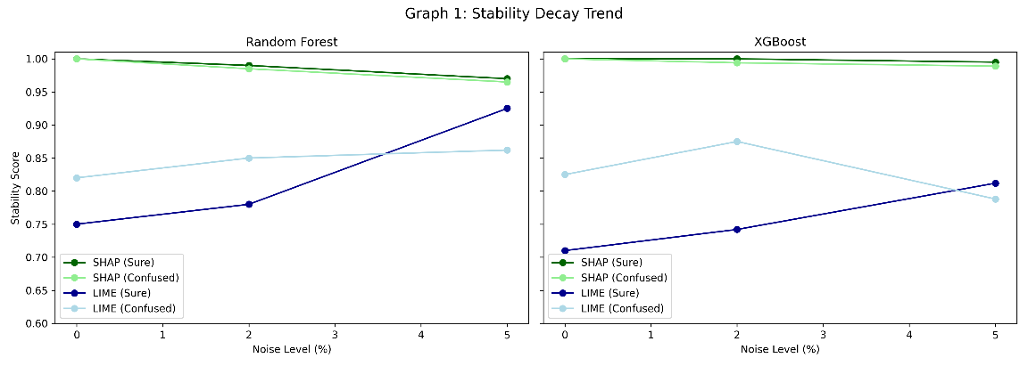
Figure 1
Figure 1 illustrates the stability decay of SHAP and LIME explanations as input noise increases from 0% to 5% for both Random Forest and XGBoost models. Across all configurations, SHAP exhibits consistently high stability, with only marginal degradation under increasing noise. This behavior aligns with prior findings that attribution-based methods grounded in additive feature contributions tend to be more robust to small perturbations \cite{lundberg2017shap,alvarez2018robustness}.
In contrast, LIME demonstrates noticeably greater sensitivity to noise. While stability remains moderate at low noise levels, increased perturbation leads to less consistent explanations, particularly in Confused cases. Similar sensitivity of local surrogate-based explanations to input perturbations has been reported in earlier robustness analyses \cite{ghorbani2019interpretation,slack2020fooling}. These results indicate that explanation robustness deteriorates as noise increases, with the effect being substantially stronger for LIME than for SHAP.
6.2 Stability Gap in Sure vs. Confused Prediction Cases
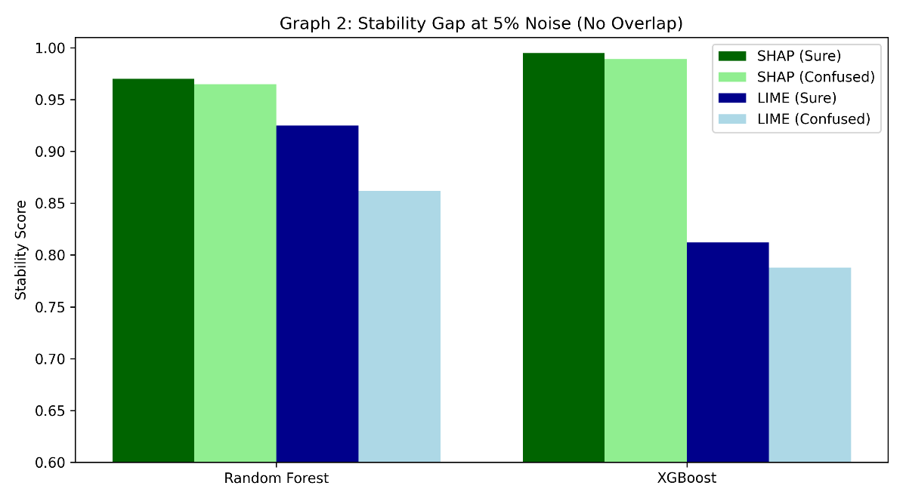
Figure 2
Figure 2 highlights the stability gap between Sure and Confused prediction cases at 5% noise. In Sure cases, both SHAP and LIME maintain relatively stable explanations, reflecting the presence of a dominant predictive signal. However, in Confused cases—where model predictions lie close to decision boundaries—LIME exhibits a sharp decline in stability, whereas SHAP remains comparatively resilient.
This behavior is consistent with prior work demonstrating that explanation sensitivity increases near decision boundaries, where small perturbations can significantly alter local model behavior \cite{alvarez2018robustness,ghorbani2019interpretation}. The pronounced Stability Gap observed for LIME suggests that local surrogate explanations are particularly vulnerable when both input noise and prediction uncertainty are present.
6.3 Model–XAI Interaction Analysis
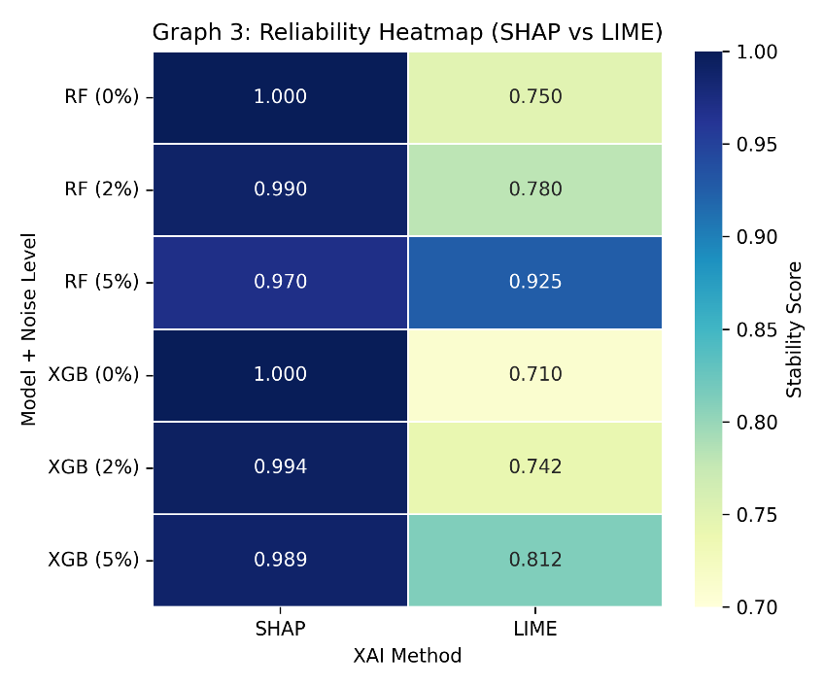
Figure 3
Figure 3 presents a heatmap summarizing explanation stability across predictive models, noise levels, and explainability techniques. The heatmap reveals that SHAP maintains high stability across both Random Forest and XGBoost, even under higher noise levels. This consistency suggests that SHAP’s robustness is largely model-agnostic, corroborating earlier findings in tabular explainability studies \cite{lundberg2017shap,yeh2019fidelity}.
Conversely, LIME exhibits lower and more variable stability across all configurations, regardless of the predictive model. This pattern reinforces the conclusion that explanation instability arises primarily from the explanation mechanism itself rather than from the underlying classifier, as also observed in prior comparative studies of explanation methods \cite{slack2020fooling}.
6.4 Summary of Key Findings
The experimental results collectively demonstrate that:
- SHAP explanations exhibit high and consistent stability across noise levels, confidence regimes, and predictive models.
- LIME explanations are significantly more sensitive to noise, particularly in Confused prediction cases.
- A pronounced Stability Gap emerges under high noise and low-confidence conditions, where explanation reliability is most critical.
- The robustness patterns are consistent across Random Forest and XGBoost, indicating model-agnostic explanation behavior.
These findings highlight explanation stability as a crucial, yet often overlooked, dimension of explainable AI evaluation in precision agriculture.
7. Discussions
This section interprets the empirical findings in light of existing research on explainable AI robustness and discusses their implications for crop recommendation systems and precision agriculture.
7.1 Explanation Stability and Noise Sensitivity
The observed stability decay trends suggest that explanation robustness is fundamentally influenced by the underlying explanation strategy. SHAP’s additive attribution framework aggregates feature contributions across multiple coalitions, resulting in explanations that are less sensitive to localized input perturbations \cite{lundberg2017shap}. This aggregation effect likely explains SHAP’s ability to maintain stable explanations even under increasing noise.
By contrast, LIME relies on locally sampled perturbations and surrogate modeling, making it inherently sensitive to how the local neighborhood is defined. As noise increases, the local approximation can change substantially, leading to unstable explanations—a limitation that has been previously documented in robustness studies \cite{alvarez2018robustness,slack2020fooling}.
7.2 Stability Gap and Decision Boundary Effects
The pronounced Stability Gap observed in Confused prediction cases can be attributed to the interaction between explanation mechanisms and model uncertainty. Confused cases correspond to regions near decision boundaries, where small perturbations can significantly affect model behavior. Prior work has shown that explanations tend to be most unstable in these regions, particularly for local explanation methods \cite{ghorbani2019interpretation}.
SHAP’s relatively stable behavior in Confused cases suggests that its explanation mechanism is less influenced by local decision boundary fluctuations. This distinction is critical in agricultural decision-support systems, where ambiguous conditions are common and explanations must remain reliable to support informed decision-making.
7.3 Implications for Trust and Deployment in Agriculture
In practical agricultural settings, unstable explanations can undermine user trust, even when model predictions are accurate. If explanations shift across minor sensor variations, users may struggle to act upon the recommendations. Prior studies emphasize that trust in AI systems depends not only on transparency but also on explanation reliability \cite{yeh2019fidelity}.
The findings of this study suggest that SHAP is better suited for deployment in crop recommendation systems operating under noisy conditions. Conversely, the instability observed for LIME in low-confidence scenarios highlights the need for caution when applying local surrogate explanations in high-stakes agricultural contexts.
7.4 Broader Implications for Explainable AI Evaluation
Beyond agriculture, the results reinforce the need to treat explanation stability as a core evaluation dimension in explainable AI. Many existing studies emphasize interpretability and fidelity without systematically assessing robustness. Recent work has called for more rigorous evaluation frameworks that account for noise and uncertainty \cite{alvarez2018robustness,yeh2019fidelity}, and the present study contributes empirical evidence supporting this direction.
7.5 Limitations
While the findings are consistent across models and noise levels, this study is limited to a single dataset and simulated noise conditions. Real-world sensor error distributions and additional explanation techniques may exhibit different behavior. Nevertheless, the consistency of the observed patterns suggests that the identified Stability Gap reflects a general property of explanation methods rather than a dataset-specific artifact.
8. Conclusion
This paper investigated the robustness of explainable AI methods in the context of crop recommendation systems by systematically analyzing the stability of SHAP and LIME explanations under realistic input noise and varying prediction confidence. While existing studies primarily emphasize predictive accuracy and explanation interpretability, this work demonstrates that explanation stability is a critical and often overlooked requirement for trustworthy agricultural decision-support systems.
Through controlled noise injection and repeated perturbation analysis, the study revealed that SHAP consistently provides more stable and reliable explanations than LIME across noise levels, predictive models, and confidence regimes. In contrast, LIME exhibits significant sensitivity to input perturbations, particularly in Confused prediction cases, leading to a pronounced Stability Gap when both model uncertainty and noise are present. These findings align with broader concerns raised in explainable AI robustness literature regarding the fragility of local surrogate explanations near decision boundaries \cite{alvarez2018robustness,ghorbani2019interpretation}.
Importantly, the observed stability patterns remain consistent across both Random Forest and XGBoost models, indicating that explanation instability is largely method-dependent rather than model-dependent. This model-agnostic behavior strengthens the generality of the findings and underscores the need for stability-aware evaluation of explanation methods in real-world deployments.
From a practical perspective, the results highlight that unstable explanations can undermine user trust, even when predictive performance is high. In precision agriculture, where recommendations influence economically significant decisions, explanation reliability is essential for adoption and effective use. Based on the empirical evidence presented, SHAP emerges as a more suitable explainability method for crop recommendation systems operating under noisy and uncertain conditions.
Overall, this work contributes a structured evaluation framework for explanation stability and provides empirical insights that advance the understanding of explainable AI reliability in agriculture and beyond. The findings advocate for incorporating robustness considerations into the design, evaluation, and deployment of explainable AI systems in high-stakes domains \cite{yeh2019fidelity,lundberg2017shap}.
9. Future Work
While this study provides empirical evidence of explanation stability differences between SHAP and LIME in crop recommendation systems, several promising directions remain for future research.
First, the evaluation can be extended to larger and more diverse datasets, including multi-seasonal data and region-specific agricultural datasets. Incorporating data from different geographic locations and crop cycles would allow investigation of whether explanation stability patterns persist across varying agronomic conditions and environmental distributions.
Second, future work may explore additional explainability methods, such as Anchor explanations, Integrated Gradients, or counterfactual-based approaches. Comparing these techniques under the same noise-aware evaluation framework would provide deeper insights into whether robustness issues are inherent to local explanations or vary across explanation paradigms.
Third, the current noise injection strategy simulates generic sensor perturbations. A more realistic evaluation could incorporate sensor-specific error models derived from real agricultural sensing devices. This would allow explanation stability to be assessed under noise distributions that more accurately reflect operational deployment conditions.
Another important direction involves the development of stability-aware explanation interfaces for end users. Rather than presenting explanations alone, future systems could provide stability scores or confidence indicators alongside explanations, enabling farmers to better judge the reliability of the recommendation rationale.
Finally, extending the analysis to real-time and interactive deployment scenarios, such as mobile or web-based advisory platforms, would help bridge the gap between experimental evaluation and practical adoption. Integrating explanation stability assessment into live decision-support systems could play a crucial role in improving trust, transparency, and long-term usability of AI-driven agricultural technologies.

